Logic Gates
- What input bit patterns will cause the following circuit to produce an output of 1?
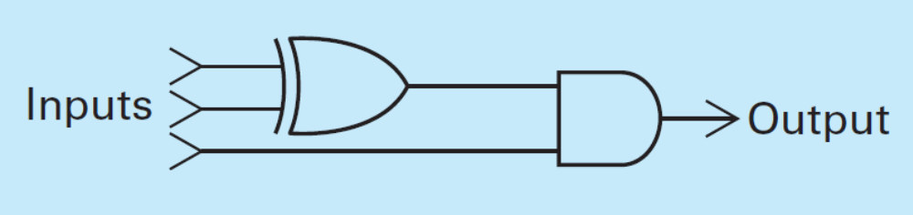
101
- If the output of an AND gate is passed through a NOT gate, the combination computes the Boolean operation called NAND, which has an output of 0 only when both its inputs are 1. The symbol for a NAND gate is the same as an AND gate except that it has a circle at its output. The following is a circuit containing a NAND gate. What Boolean operation does the circuit compute?
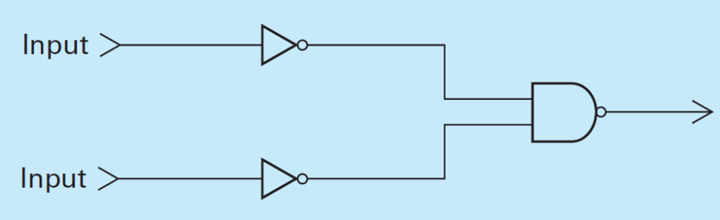
0 0 -> 1 1 -> 0
1 1 -> 0 0 -> 1
0 1 -> 1 0 -> 1
1 0 -> 0 1 -> 1
OR gate
- If the output of an OR gate is passed through a NOT gate, the combination computes the Boolean operation called NOR that has an output of 1 only when both its inputs are 0. The symbol for a NOR gate is the same as an OR gate except that it has a circle at its output. The following is a circuit containing an AND gate and two NOR gates. What Boolean operation does the circuit compute?
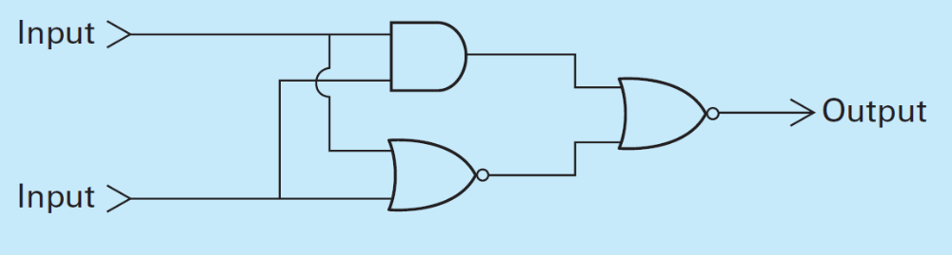
1 1 -> 1, 0 -> 0
1 0 -> 0, 0 -> 1
0 1 -> 0, 0 -> 1
0 0 -> 0, 1 -> 0
XOR gate

Hexadecimal Notation
- Use hexadecimal notation to represent the following bit patterns:
  - 0110101011110010 0110 1010 1111 0010 6AF2
  - 111010000101010100010111 1110 1000 0101 0101 0001 0111: E8557
  - 01001000 0100 1000: 48

- What bit patterns are represented by the following hexadecimal patterns?
  - 5FD97 0101 1111 1101 0111
  - 610A 0110 0001 0000 1010
  - ABCD 1010 1011 1100 1101
  - 0100 0000 0001 0000 0000

ASCII Encoding for Text
- Here is a message encoded in ASCII using 8 bits per symbol. What does it say? (See Appendix A)
01000011 01101111 01101101 01110000 01110101 01110100
01100101 01110010 00100000 01010011 01100011 01101001
01100101 01101110 01100011 01100101
- Encode these sentences in ASCII:
  - “Stop!” Cheryl shouted.
  - Does 2 + 3 = 5?

Binary Notation
- Convert each of the following binary representations to its equivalent base ten form:
  - 0101
  - 1001
  - 1011
  - 0110
  - 10000
  - 10010
- Convert each of the following base ten representations to its equivalent binary form:
  - 6
  - 13
  - 11
  - 18
  - 27
  - 4
- What is the largest numeric value that could be represented with three bytes if each digit were encoded using one ASCII pattern per byte? What if binary notation were used?
999
16,777,216
- An alternative to hexadecimal notation for representing bit patterns is dotted decimal notation in which each byte in the pattern is represented by its base ten equivalent. In turn, these byte representations are separated by periods. For example, 12.5 represents the pattern 0000110000000101 (the byte 00001100 is represented by 12, and 00000101 is represented by 5), and the pattern 100010000001000000000111 is represented by 136.16.7. Represent each of the following bit patterns in dotted decimal notation.
  - 0000111100001111
  - 001100110000000010000000
  - 0000101010100000

- Convert each of the following binary representations to its equivalent base ten form:
  - 101010
  - 100001
  - 10111
  - 0110
  - 11111
- Convert each of the following base ten representations to its equivalent binary form:
  - 32
  - 64
  - 96
  - 15
  - 27

Fractions in Binary
- Convert each of the following binary representations to its equivalent base ten form:
  - 11.01
  - 101.111
  - 10.1
  - 110.011
  - 0.101
- Express the following values in binary notation:
  - $4\frac{1}{2}$
  - $2\frac{3}{4}$
  - $1\frac{1}{8}$
  - $\frac{5}{16}$
  - $5\frac{5}{8}$
- Perform the following additions in binary notation:
  - 11011 + 1100
  - 1010.001 + 1.101
  - 11111 + 0001
  - 111.11 + 00.01

